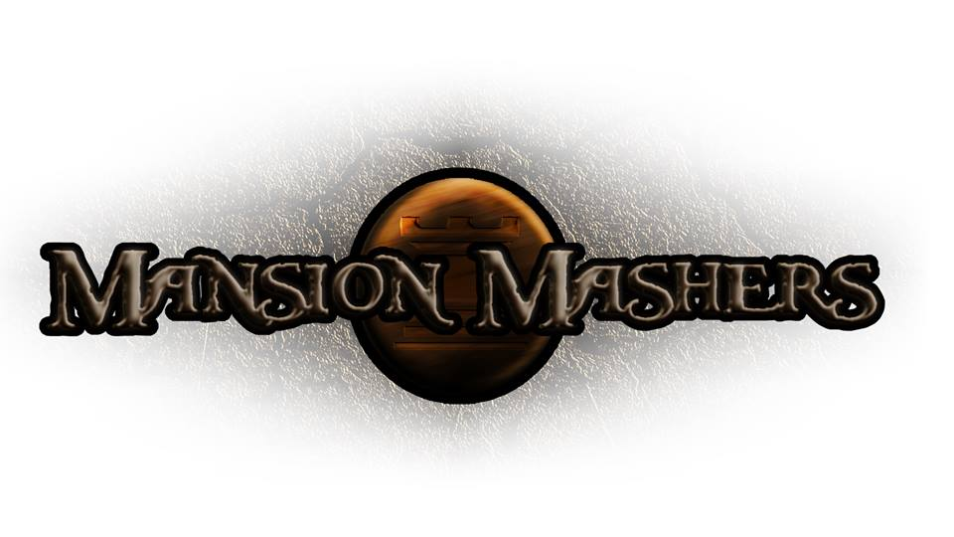**Weekly Production Report**

**Week 10**

**March 13, 2014**

**By Juli Gregg**

**High Concept**:

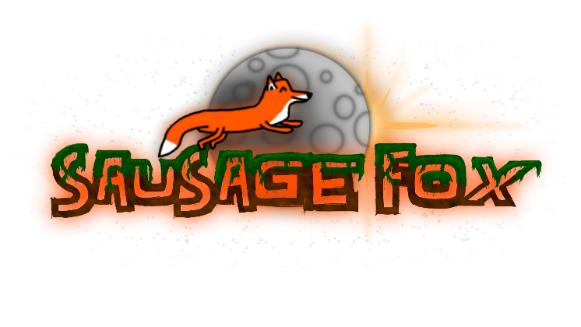A 2-D fast-paced, side scrolling hack and slash game set in a cartoon fantasy world with character ability progression.

**Producer:**

Juli Gregg

**Tech Director**:

Dan Muller

**Game Designer**:

Luke Conlon

**Product Manager**:

Kaden Nugent

Project Status:

Green

Current Milestone:

Alpha

Accomplishments:

|  |  |
| --- | --- |
| **Juli Gregg:** | Added spawners, platforms, walls, and background art to Level 2. Created a death screen. Helped with camera and barrier locks for fighting. Connected health to power-ups. Created presentation assets. Fixed Restart issue. |
| **Dan Muller:** | Added mouse movement for map as well as gating map based on progress. Updated in-game text. Added a Quit confirmation. Finished up first boss mechanics and placeholder art/animations. Fixed memory issues and smoothed player drop down through platforms. |
| **Luke Conlon:** | Added AI to enemies for dealing with walls. Helped with camera and barrier locks for fighting. Fixed bugs with particles and moonwalking. Made HUD update health bar. Began to polish up some art assets. Have weapons update player stats. |
| **Kaden Nugent:** | Continued to fix Memory issues. Fixed pause menu and added ability to update a button’s position. Added new portions/rooms to the tutorial including an obstacle course. |

Objectives:

|  |  |
| --- | --- |
| **Juli Gregg:** | Work with Luke over spring break to get a lot of background art done. Place platform, walls and spawners to levels. Implement camera movement/barriers based on fighting portions of levels. |
| **Dan Muller:** | Begin work on other boss AI. |
| **Luke Conlon:** | Work with Juli over spring break to get a lot of background art done. Work on boss art. Develop a “bigger” enemy and its AI. Work on some later boss AI. |
| **Kaden Nugent:** | Finish the tutorial and make sure player learns everything they need to know to play game. Put sound assets into appropriate places. Fix memory leaks as the come up. |

Group Accomplishments:

|  |  |
| --- | --- |
| **Weekly Group Meeting** | Discussed some issues and what we wanted to show at Alpha Presentations. |
| **Repository**  **Commit Stats** | This week: 64  In a month: 328 |

Group Objectives:

|  |  |
| --- | --- |
| **Weekly Group Meeting** | We don’t plan to have a meeting until the weekend before break ends. We plan to discuss where we want sounds to be within the game. |

Highlights:

Dan was excited for Titanfall. Luke was excited that he was talking to Mark Ward. Kaden was also excited to have talked to Mark Ward this week.

Risks & Mitigations:

|  |  |
| --- | --- |
| **RISKS:** | (1) We have a lot of plans for this game that due to limited amount of time we may not be able to implement everything that we want to.  (2) Class work load has increased a significant amount the past week.  (3) A lot of art and sound assets still need to be made and added to the game. |
| **MITIGATIONS:** | (1) Attempt to keep a realistic timeline and slowly weave in stretch goals as we achieve the basic requirements to make our game functional and fun.  (2) We worked to stay ahead by trying to finish assignments early.  (3) We plan to work over spring break. |

**Signatures**

_____________________

Juli Gregg

_____________________

Dan Muller

_____________________

Luke Conlon

_____________________

Kaden Nugent